Problem No: 2

Problem Statement: Generate and plot sine and cosine waves using MATLAB.

Codes:
clc; clear;close all;
A = 1;f = 5; t = 0:0.001:1;
y1 = A * sin(2pif*t);
y2 = A * cos(2pif*t);
disp(t);
figure;
plot(t,y1); hold on;
plot(t,y2) hold off; grid on;
legend('Sine Wave', 'Cosine Wave'); title("Sine wave");
xlabel("Time (s)");
ylabel("Amplitude");

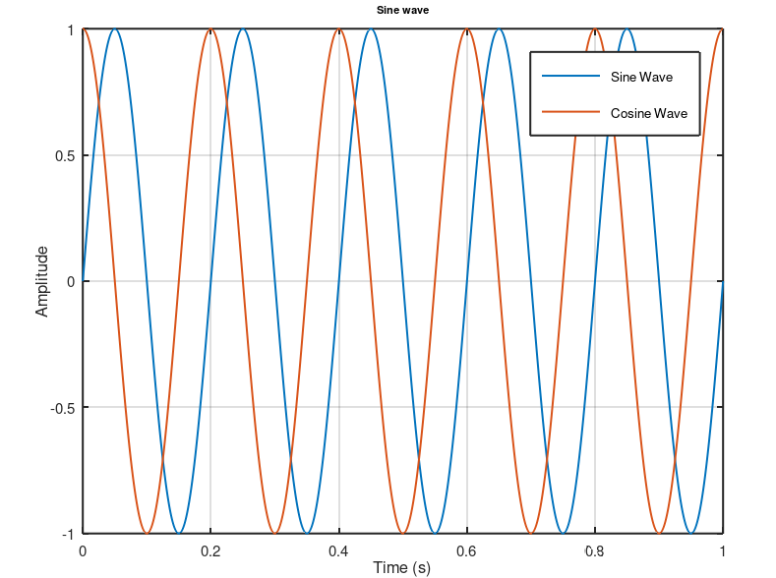
Output:

